Three Axis CNC Milling Machine

CNC Bed Size: 1Meter x 2Meter
A Computer Numerical Control machine, more commonly known as a CNC machine is method used for automating the control of machining tools by using a computer software. The first CNC machines were developed in 1940s and 1950s and since then have gradually evolved to become an integral part of production processes, fabrication, machining, etc. CNC machines have time and again proved to be objectively superior to non-computerised methods of machining that must be manually controlled. By automating the process of machining and reducing the need for human intervention, CNC systems not only reduce the human effort required but also decrease the margin for error.
This Three Axis CNC machine uses an array of three stepper motors for engraving and cutting.
Since this system can work with a variety of materials such as various types of wood, MDF, PCB, etc. it is exceptionally versatile and can be used for a wide purposes like woodworking, PCB printing etc.
Moreover, along with being extremely accurate and versatile, this system is compatible with Mach 3 making it extremely easy to program.
CNC machines can fabricate complex designs repeatedly while simultaneously making sure that there is no loss of accuracy and consistency.
Features of three axis CNC Milling Machine:
- Three axes for drilling, cutting, and engraving.
- Motorized operation using 3 stepper motors.
- User friendly operation
- Compatible with Mach 3
- Works with multiple materials (wood, MDF, PCB, etc.)
The system makes use of 3 x Stepper motors along with a high speed motor for the milling, cutting tool. The entire system receives program instructions from a computer software to achieve desired milling, cutting results.
The machine is driven by 3 Stepper motors, one for x motion one for Y motion and the third for bringing down the bit motor on the work surface. The third motor defines the milling cutting depth. The 3 Motors work in coordination to achieve desired results.
The motors are controlled by a CNC controller box which consists of 3 Stepper controllers and cooling fan. These stepper drivers are provided instructions by a decoder interface board that receives serial data via a computer by a MACH 3 or compatible software.

Components:
- Stepper Motor
- Drill Motor
- Stepper Motor Driver
- Ball Screws
- Milling/Drilling Bits
- Mach 3 Interface Board
- Cooling Fan
- Supporting Rods and Couplings
- Couplings
- Bed Frame
- Stepper Motor Mount
- Mounts and Joints
- Screws and Bolts

Applications:
- Capable of drilling, cutting, and engraving furniture, machine partsetc
- Can be used for seamlessly creating complex designs in wood with extreme accuracy.
- Also compatible with MDF.
- Useful for manufacturing PCB.

Advantages:
- Useful for drilling, cutting, and engraving.
- User friendly Easy to program
- Extremely versatile and can be used with a wide range of materials.
- Can be used for woodworking, carving, engraving, manufacturing PCB etc.

Disadvantages:

Block Diagram:

Top View
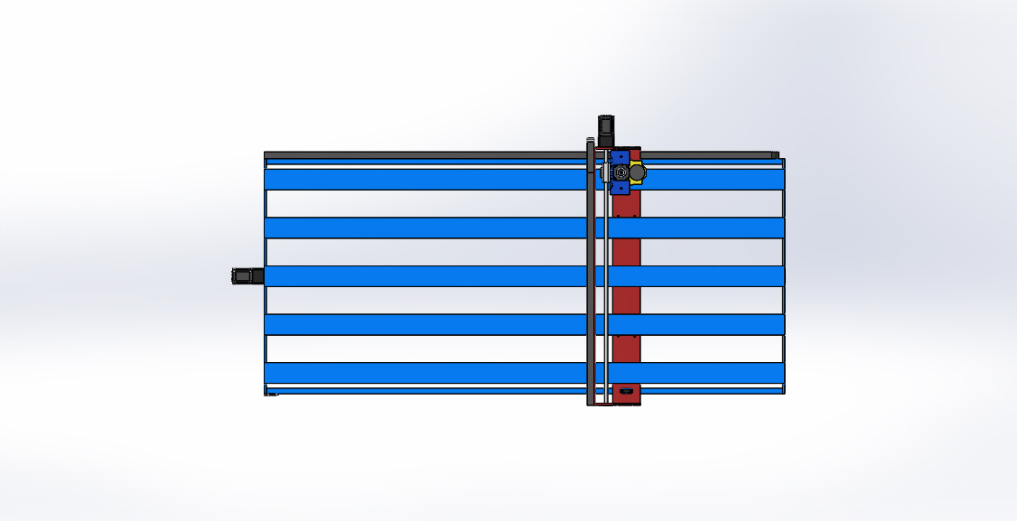

Side View
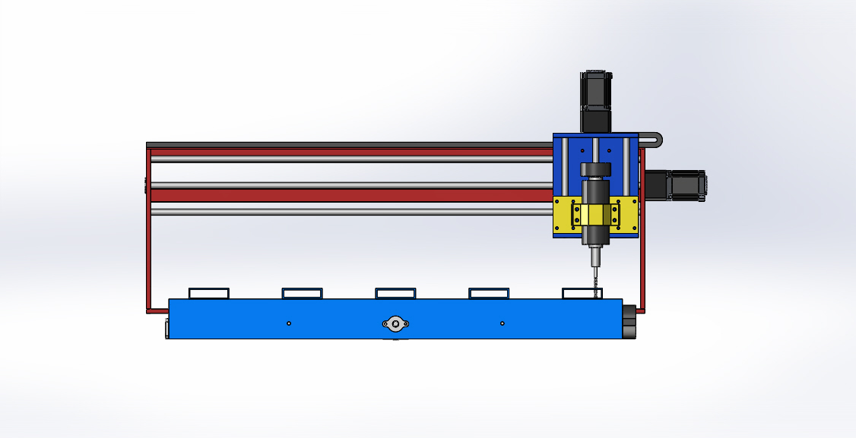

3D View

